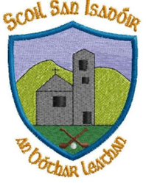

Annual Admissions Notice September 2023
A copy of the school’s Admission Policy and the Application Form for Admission for the 2024/2025 school year is available as follows: – To download at: www.boherlahanns.com On request: By emailing boherlahanns@gmail.com or writing to: Scoil San Isadóir, Boherlahan, Cashel, Co. Tipperary

Application and Decision Dates for admission to 2024/2025
The following are the dates applicable for admission to Junior Infants
The school will commence accepting applications for admission | September 2023
The school shall cease accepting applications for admission on | 27th October 2023
The date by which applicants will be notified of the decision on their application | 7th December 2023
The period within which applicants must confirm acceptance of an offer of admission is 21 st December 2023 | 21st December 2023
*Failure to accept an offer within the prescribed period above may result in the offer being withdrawn
Note: the school will consider and issue decisions on late applications in accordance with the school’s admission policy.

