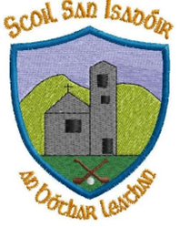
23/06/23

Dear Parents,

Just a quick message to wish you all the best for the summer holidays. Thank you for your continued support throughout the year.
The very best wishes to our graduation class heading on to secondary school. You have been absolutely fabulous! Don’t forget to come back and say hello sometime. Thanks to all involved in organising and attending the graduation ceremony last night. A very special, enjoyable night by all accounts.
Sincere thanks to John & Mairead Tarrant who sponsored our Dolce Vita Ice-Cream surprise on sports day. We sincerely appreciate it. Thanks to all who helped out on a fabulous fun day!
Looking forward to meeting our new Junior infants and all our students in September for a brand new school year! Enjoy the summer holidays. Thanks from all the team here in Scoil San Isadóir!
See you all on the 30th of August!
Kind regards,
Catherine Cleary
Principal

