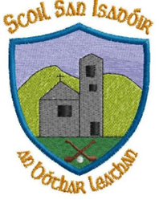
June 2023
Dear parents,
Just a quick note as we come to the end of another school year, I want to draw your attention to a few small items.
Tipp FM
We were delighted to have Tipp FM in school yesterday with 1st & 2nd class to discuss Nature Heroes, Incredible Edibles and lots lots more! Tune in every morning next week (12th – 16th June) at 8.15am to hear all about it. Well done to all involved and thanks to Teresa Delahunty for contacting Tipp FM.
Booklists for September
As we mentioned earlier on in the year your child’s schoolbooks and copies will be purchased by the school for the year ahead. There are some items that the schoolbook grant does not cover for example pencil case/ colours/ dictionaries etc. Please see the attachment with all details for the 2023-2024 school year for your child.
*If you have any dictionaries/ atlases / table books at home that you are no longer using and wish to donate to the school we will gladly take them.
* If you have any old school uniforms that are in good condition, that you are no longer using you can donate to the school too if you wish.
Bloom

Well done to all who attended bloom. A fantastic day by all accounts. Sincere thanks to Tina, Joanne, and Sinead for taking 1st and 2nd class on this trip. Sincere apologies about the delays on Friday evening.
Dates for your diary
- Green Schools Clothes collection: Last day to drop in clothes 14th June
- Sports Day: June 16th
- Reminder: parents welcome to morning assembly for medal presentation June 16th
- 6th class Graduation June 22nd
- Summer Holidays: School closing 23rd June 12 O’clock

Sincere thanks for all your support throughout the year. Please do not hesitate to contact me should you have any queries.

Kind regards
Catherine Cleary
Principal

