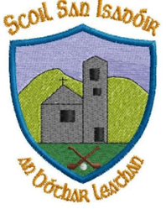

20th December 2022

Dear parents,

As we come to the end of first term, we would like to take this opportunity to wish you all a safe and happy Christmas and to thank you all for your continued support.

Sincere thanks also to our Parents Association for all their help and support throughout the term and with all our Christmas festivities including the selection boxes, especially Kathryn, David and Brendan who sorted out our Christmas lights! Thank you. A special word of thanks to Ger, Sinead and Darragh Doyle for hanging up all our bird boxes and bat boxes. It is sincerely appreciated. Our Green Schools Nature Heroes are delighted.

We are delighted to tell you that we raised €321.60 for the Kick it for Corey Campaign. Thank you for your kindness and generosity.

We hope that you enjoyed our Carol Service and Christmas Blessing last Thursday. Special word of thanks to our musicians Niall, Clodagh and Ciara under the wonderful guidance of Múinteoir Sharon and to all our teachers and SNAs for making the afternoon so special. The children were absolutely superb. Videos and photos will be added to our website over the coming days. www.boherlahanns.com

Have a safe and happy Christmas.

Warm regards,
Catherine Cleary

